Answer of Q4 :_Detailed Execution Plan and Results (for UI Test)

The UI Test Cases has been written and executed as well and also give here: Manual Testing Assessment.xlsx.
Please see the test scenarios and the Test cases written and executed with status.

Here is the Process of the test cases by going to the site and process for the happy path scenarios.

Search Functionality :
- Action: Go to https://demo.evershop.io/, type “Nike react” in the search bar, and press Enter.
- Expected Result: Product list appears with “Nike react” shoes.
- Actual Result: Nike react shoes appeared with color and size options.
- Status: Pass
- Screenshot: 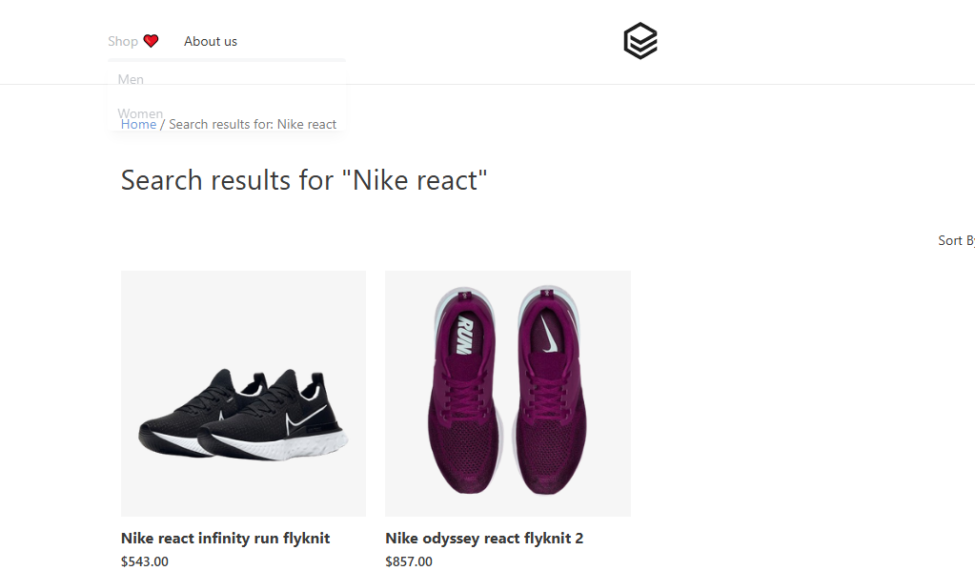

Product Selection:
- Action: Click on the first product in the results.
- Expected Result: Product detail page opens showing multiple color and size options.
- Actual Result: Product details showed successfully.
- Status: Pass
- Screenshot: 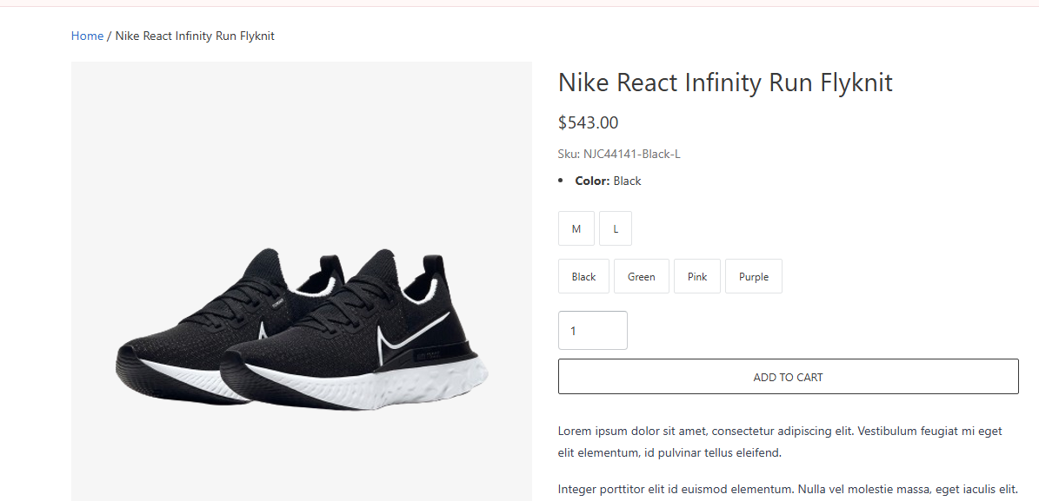

3.Add Variants to Cart:
Perform any one among the 4 actions:
- Add Small (Black)
- Add Medium (White)
- Add Large (Green)
- Add Large (Red)
For each addition:
- Expected Result: A confirmation popup or cart counter updates successfully.
- Actual Result: Product size and color can be selected or added successfully.
- Status: Pass
- Screenshot: 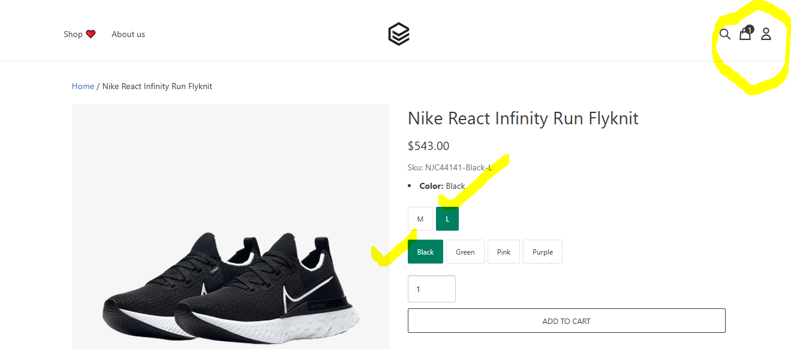

4.Verify Cart Page :
- Action: Click on the cart icon → Go to Cart page.
- Expected Result:
All selected items should be visible with correct details
- Actual Result:All selected items visible with correct details after going to the cart page. Quantity and Price is also showing.
- Status: Pass
- Screenshot:
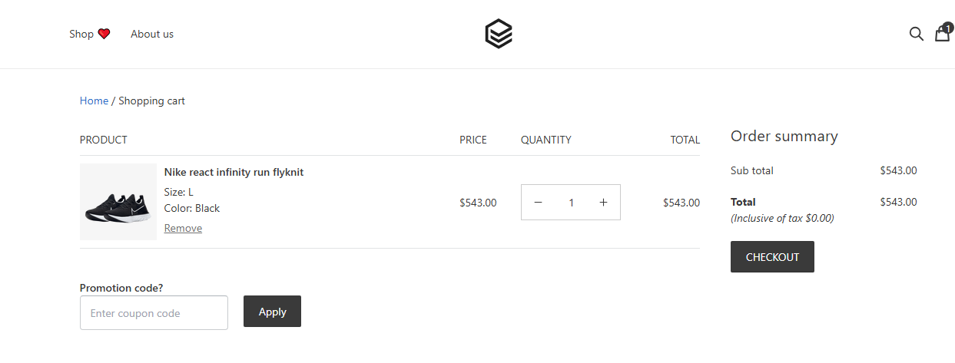
Therefore, In the UI level Happy Path scenario, there was no bug/Defect found. I checked for only one product and see that there was no error.

